
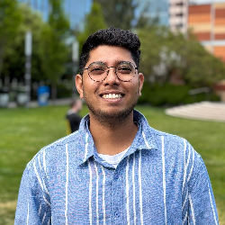
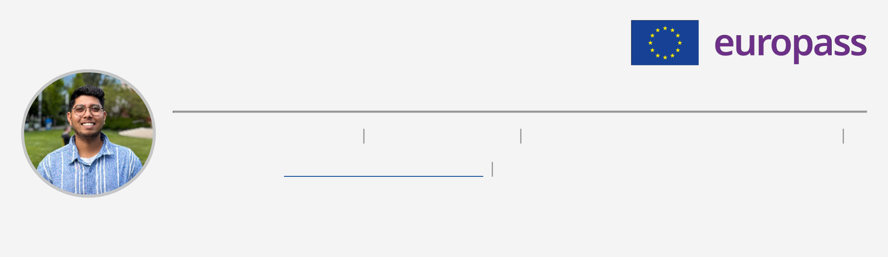
Rohit kadam
Date of birth: 14/10/1996 | Nationality: Indian | Phone number: (+91) 7767880235 (Mobile)
Email address:
Address: Flat No.308, RKL Anand Phase 1,Tathwade, Near Tata Motors Excel vehicles Pune, 411033 Pune (India), 411033, Pune, India (Home)
ABOUT ME
Data scientist with 4 years building AI systems for healthcare and clinical trials. Patent holder, published researcher, presented at PharmaSUG conferences. Focus on NLP, GenAI, and making clinical workflows faster.
WORK EXPERIENCE
TATA CONSULTANCY SERVICES – PUNE, INDIA
I.T. ANALYST – 01/01/2024 – CURRENT
• Led the development of a GenAI-based medical assistant using Azure OpenAI, improving monitoring process efficiency in clinical trials.
• Directed a team of 4 in building modular LLM applications with retrieval-augmented generation (RAG) for literature management systems.
• Acted as primary point of contact for stakeholders during pilot solution rollout, ensuring smooth adoption.
• Conducted cross-team brainstorming and stakeholder interviews to define new HealthTech use-cases.• Designed and implemented an API-driven platform for real-time medical monitoring and actionable insights in clinical trial decision making.
• Facilitated stakeholder engagement as primary contact for pilot rollouts; coordinated feedback and successful solution adoption across departments.
TATA CONSULTANCY SERVICES – PUNE, INDIA
SYSTEM ENGINEER – 01/07/2021 – 31/12/2023
• Developed a regulatory intelligence chatbot using RASA and custom NLP models, reducing regulatory query response time for professionals.
• Collaborated with subject matter experts and business leads to design AI-driven healthcare pilots for pharma clients.
• Served as Innovation Lead during an Incubation Bootcamp, resulting in an award-winning product idea for AI- driven healthcare pilots.
• Mentored three junior interns in Python, NLP, and AI/ML fundamentals, supporting their proof-of-concept (POC) projects.
• Initiated and led a knowledge-sharing forum within the Regulatory Intelligence team for accelerating GenAI adoption across organizational verticals.
TATA CONSULTANCY SERVICES – PUNE, INDIA
ASSISTANT SYSTEM ENGINEER – 14/09/2020 – 30/06/2021
• Contributed to data analysis and dashboard creation for EHR analytics platforms using Python.
• Supported initial experiments with NLP applied to medical writing and document summarization.• Acted as primary contact for POC development to streamline transition from EHR data to EDC systems.
WAKIDOK INNOVATIVE SOLUTIONS – PUNE, INDIA

BUSINESS DEVELOPMENT EXECUTIVE – 01/11/2018 – 31/03/2019
• Actively Conducting Market Research
• Creating and implementing actionable business strategies to expand the customer base and increase revenue
PROJECTS
2025
Literature Intelligence Platform

• Automated analysis of 1000+ medical publications for pharmacovigilance applications• Achieved 60% precision in safety report detection, saving in manual review costs• Demonstrated clear business value proposition for pharmaceutical safety operations

2024
GenAI Medical Monitoring Assistant

• Production system supporting clinical trials with measurable efficiency gains in safety monitoring• Reduced safety signal detection time by 35%, directly impacting trial timelines and operational costs• API-based architecture enabling scalability across multiple functions
CONFERENCES AND SEMINARS
31/05/2025 – 04/06/2025 San Diego, California
PharmaSUG 2025 U.S.

"Leveraging Generative AI for signal detection, safety reviews, and evidence gathering in Medical Literature" - explored business and operational implications of AI in pharmacovigilance workflows
Link
19/05/2024 – 22/05/2024 Baltimore, MD
PharmaSUG 2024 U.S.

"LLM-Powered Regulatory Intelligence Platforms" - discussed technology convergence and its impact on regulatory business processes.
Link
PUBLICATIONS
2022
The Future of Regulatory Intelligence With Conversational AI

The articles discussed how the regulatory chatbot efficiently bridges the gap between users and vast regulatory data worldwide, offering user-friendly and easy-to-understand responses, increasing usability in the life sciences domain.

2022
AI/ML Approaches to Assisted Medical Writing—Part 1 - Jun 21, 2022

Explored the approach of Abstractive and extractive summarization for medical writing.

2022
AI/ML Approaches to Assisted Medical Writing—Part 2

Discusses the method of pure abstraction in light of recent advances in deep learning and AI.

2021
Future of Clinical Trial Documentation Management: eTMF Integrated with Blockchain

The article discusses how use of blockchain will help in the digitization of eTMF.

EDUCATION AND TRAINING
01/07/2014 – 29/05/2018 Sangli, India
BACHELOR OF TECHNOLOGY Rajarambapu Institute of Technology, Rajaramnagar (Shivaji University)

01/06/2012 – 15/05/2014 Satara , India
H.S.C Yashawantrao Chavan Institute of Science, Satara

01/06/2011 – 15/05/2012 Satara , India
S.S.C Maharaja Sayajirao Vidyalaya, Satara

SKILLS | Azure | AWS | Data Science | RASA | Machine Learning, NLP | OpenAI | REST API | AWS (BEDROCK)
Python
LANGUAGE SKILLS
Mother tongue(s): MARATHI
Other language(s): | UNDERSTANDING |  | SPEAKING |  | WRITING
 | Listening | Reading | Spoken production Spoken interaction
ENGLISH | C1 | C2 | C1 | C1 | B2

Levels: A1 and A2: Basic user; B1 and B2: Independent user; C1 and C2: Proficient user
PATENT
2023
Patent Grant: Automated continuous validation for regulatory compliance of a computer system (cs) comprising a dynamic component

The innovative approach to address the challenge of validating Computer Systems (CS) with dynamic components. It introduces an automated continuous validation method for regulatory compliance, incorporating User Acceptance Testing (UAT) with varying test cases and synthetic data. The process includes base validation testing with clean and dirty data, followed by learning saturation testing for dynamic component rollout in the production environment.
Link
2024
Automated Clinical Event and Endpoint Adjudication System

Contributed to the development of a novel system and method for automating clinical event adjudication in clinical trials.

Link

